**Group 9 ((Gordon) Chi Wai Tsui, (Sam) Ho Sum Chan, Grantly Tong)**

**Sample Run #1**

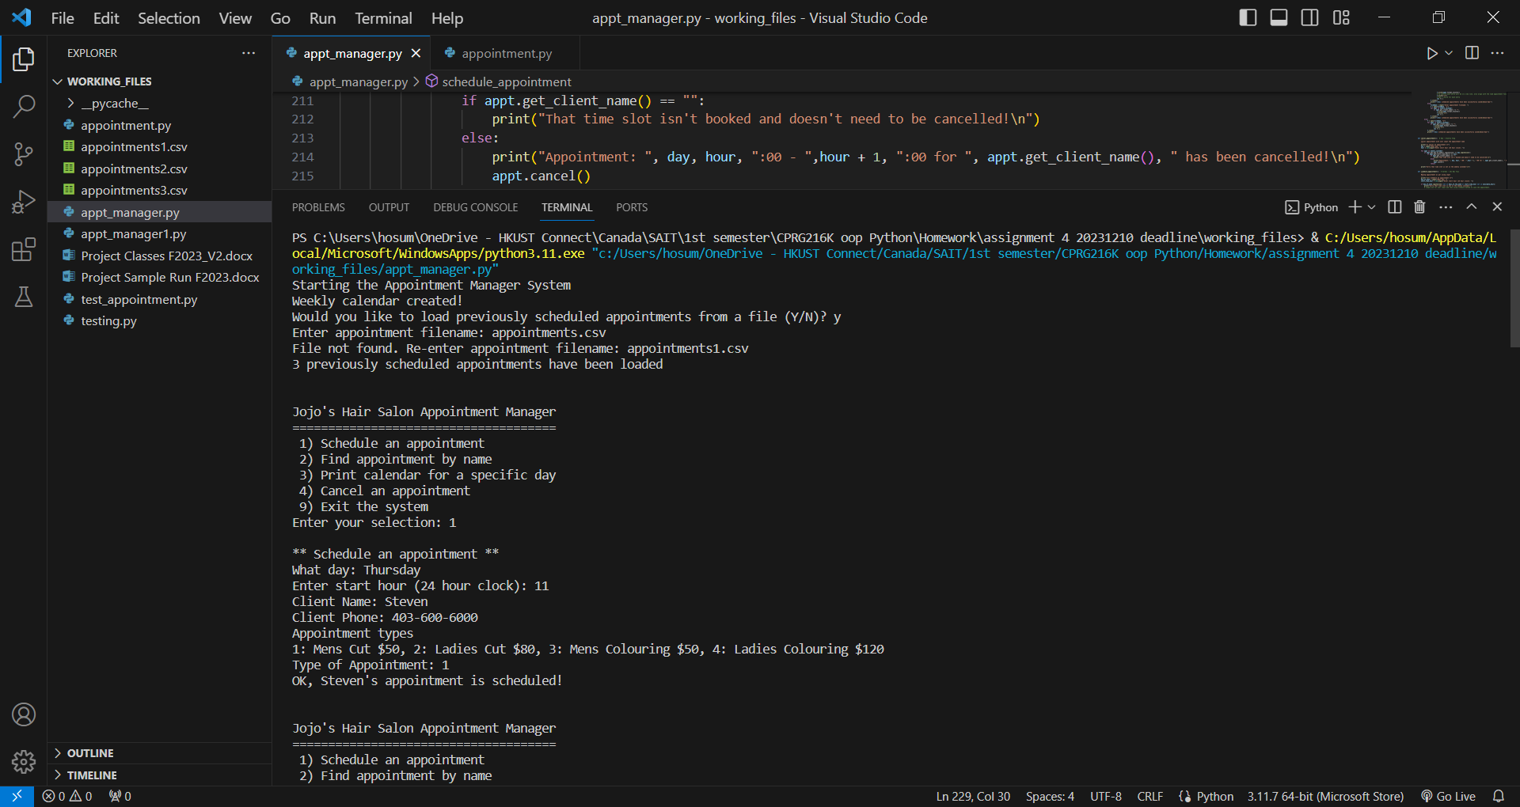

**Sample Run #2**

